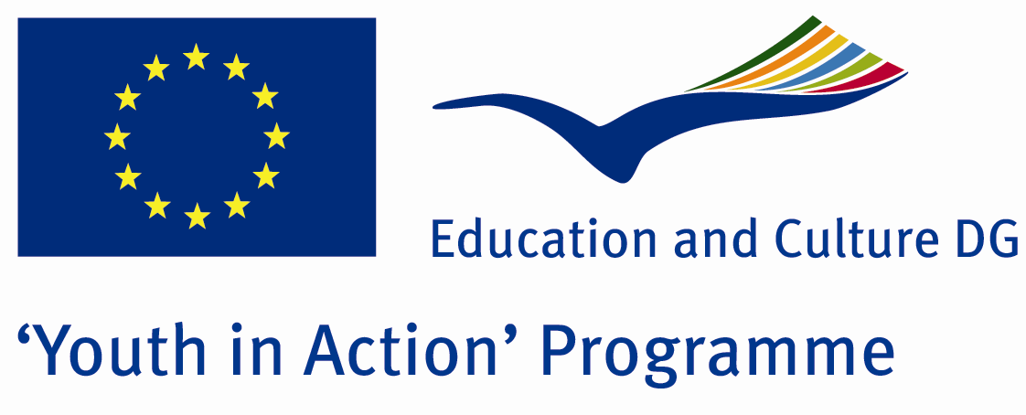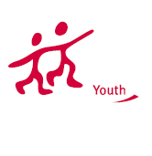

Action 4.3
Project Summary;

Get a life form genes transferring work to another creature 'Genetically Modified Organism (GMO) is called. However, the health damages of genetically modified foods, the most significant role in the world of discussion topics. GMO seeds, resistance to antibiotics, severe allergies, long-term animal experiments, organ damage, organ shrinkage, deterioration of the blood biochemistry, sterility, stillbirth, severe increase in the rate of stillbirth, in future generations such as lack of size and scale to cause negativity is causing. Although the GMO s effects on humans is not known yet determined their effects on animals. For a number of methods and chemicals used on GMOs, but rather claims that have been tried on the least developed and developing countries. In short, GMOs testing labs are poorest countries!!!

Project Title; Genetically Modified Organism
Date and Venue ; 04-10 February 2012 Turkey
Place: Hatay.

Target Group ; Municipalities, City Councils and Non-Governmental organizations,
youth groups,culture and art groups,e.t.c

Participants ; 5 people from each country (over 18 -25 ). Totally 8 countries.

Conditions ; Accommodation, board and programme costs will be financed through European Commission Youth in Action Programme . Travel costs will be reimbursed in 70% (APEX Tarrifs). Organizations from all 27 EU member countries plus Liechtenstein , Norway and Iceland are eligible to take part.

Working language: English

Organisator group: Adventurer Youthfulness Group

How to apply: If you are interested, please send your Part III forms to
by e-mail please (in word file). Scan Part3 format is enough for application.(Fulfilled Part III which you can find in the attachment, of course signed and stamped) ..

Contact e-mail: adventureryouthfulness@gmail.com

